DID YOU KNOW?
Students can spend 60 to more than 110 hours per year in test prep in high-stakes testing grades.
Including the cost of lost instructional time the estimated annual testing cost per pupil ranged from $700 to more than $1,000 per pupil in several grades that had the most testing.

Open-ended questions on standardized tests are often graded by under-paid temporary workers with no educational training
Standardized testing can cause severe stress in younger students, including vomiting, anxiety, depression and other physical issues.
Teachers and administrators can feel the burden of their entire school’s future based on the performance on standardized testing.
No school or district anywhere in the country has ever been penalized for failing to test enough (95%) of its students.
During testing season, students don’t have recess, elective classes or non-testing subjects.
Testing companies are using your child’s data, are spying on social media and are lobbying the government for more power in state curriculum choices.
THE GOOD NEWS IS…
SOLS ARE NOT REQUIRED FOR ELEMENTARY AND MIDDLE SCHOOL CHILDREN.
The rapidly accelerating testing resistance and reform movement has made significant progress to reduce standardized exams, created cutbacks in state testing mandates, made reductions in score-based consequences and suspensions of new exams - all resulting from public pressure. Parents ARE CHANGING the system!
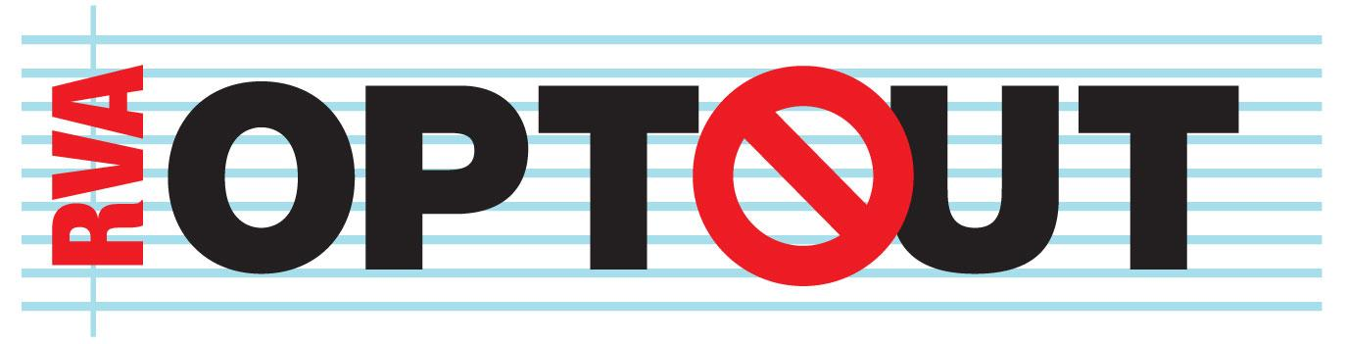
Join the local response to a nationwide movement. www.rvaoptout.com

